Event Photo Emailer

&

Facebook Uploader

Version

4.9

Developed by

Adrian A. Hood, PhD

Adrian Hood Engineering Solutions

[**info@hoodandson.com**](mailto:info@hoodandson.com)

301-437-1186

©2011

Introduction

The **Event Photo Emailer & Facebook Uploader** program was originally developed to help event photographers improve sales by providing a tool to email individual proofs to a large number of customers fast and efficiently. It has since evolved into a program that can seamlessly integrate a **“Print to Email”** & a **“Post to Facebook”** features into many existing photography software packages.

At the core, **Event Photo Emailer & Facebook Uploader** is an email engine and a Facebook app. The email engine allows emails to be sent without the need to use a traditional email program like Outlook Express. The Facebook app allows images to be posted to Facebook, into a designated album, without having to use Facebook’s uploader. Both tools work directly with many existing photo program adding very little extra time to existing workflows.

During development, the target photo program was **Express Digital Darkroom Pro® v.9.** This is mainly because this is the program the developer has been using for his workflow for over a decade. Since **Darkroom Pro®** doesn’t directly support plug-ins, a work-around solution was developed to allow for the easy integration of an email/Facebook feature into the software package.

Main Features

Works with **Darkroom Pro®[[1]](#footnote-1)** software to:

* Batch email photos (with or without graphics)
* Seamlessly integrate a “Print to Email” feature into packages
* Seamlessly integrate a “Post to Facebook” feature.
* If sending to FACEBOOK and EMAIL simultaneously, the direct link to the FACEBOOK image is included in the email.
* Automatically send photo(s) (with or without graphics) simultaneously when printing.
* Send many individuals their personal images using an email/filename directory (This mode does not need Darkroom Pro® ) This is referred to as “Print From Directory” mode

Typical Workflows

To gain an appreciation for the time saving benefits of this program, this section will describe two typical workflows:

1. An on-site, multiple portrait capture assignment that sends individuals their proofs after post-processing and
2. An on-site printingassignment that posts the images to Facebook, sends individuals their photos via email, and simultaneously produces a print.

# Example 1: On-site, multiple portrait assignment (Proofs are sent after post processing)

Suppose your assignment is to capture many different individuals/groups in front of a particular background or landmark and you would like to email everyone a proof of their images at a later time. You will capture the customer’s photo or group of photos, import them in to Darkroom Pro® (via tether, wireless, or import from the card), and then assign an email address to the corresponding photo or set of photos. This process is repeated for each set of customers for the entire assignment. Then, after post processing and removal of all undesired images, you will select all of the images in your photo gallery, batch apply your graphic template, and then run the email software and you are done! Mailing 100 emails is as easy as mailing 1! Included with each email is a customized, pre-written body message. This can range from a simple Thank You to a sophisticated advertisement.

When finished, a text file containing all the email addresses and corresponding images is generated. This email/filename directory is highly valuable for marketing purposes. For example, if the event occurs annually, Event Photo Emailer and Facebook Uploader can use the email/filename directory to easily send everyone their images again a year later with a marketing email informing them that you will be there again!

# Example 2: An on-site printing assignment that posts the images to Facebook, sends individuals their photos via email, and simultaneously produces a print.

Suppose you have a capture and print assignment at a black tie affair for an organization’s annual ball. You are to supply 5x7 prints onsite with graphic overlays as well as emails to the customer. The organization would also like for you to upload the photos to an album on their Facebook page as you take them. You would simply take the photos like you normally would… say 2 to 3 shots of each couple, highlight the images, batch apply the email address to the set of images, and then proceed with your normal workflow of choosing which image to print. Whereas before, you would simply choose a single item package that contained a single 5x7, now you would simply choose a package that contains two items: a single 5x7 and a new “Print to Email” package item. If you have an internet connection at your location, when you place your order, as the photo is being printed, it is also being emailed to the client and uploaded to Facebook. In addition to the photo, the email can contain the direct link to the same image with the organization’s Facebook album. If they have a smart phone, they may actually get the email before they get their print! If you do not have an internet connection, you would simply perform a batch process when you do get online.

Installation Instructions

* **Download Event Photo Emailer from** [www.hoodandson.com/EPE](http://www.hoodandson.com/EPEv3.zip)
  + This is a .zip file containing two items. Unzip the contents to a temporary folder. Run the Setup.exe file and follow the instructions. It is recommended that the default settings be used.
* Run “Initialize\_EPE” from the Event Photo Emailer folder in the Programs Menu (Figure 1).
  + This window will allow you generate images needed to conduct a quick test and to install features used by Darkroom Pro® (if applicable).

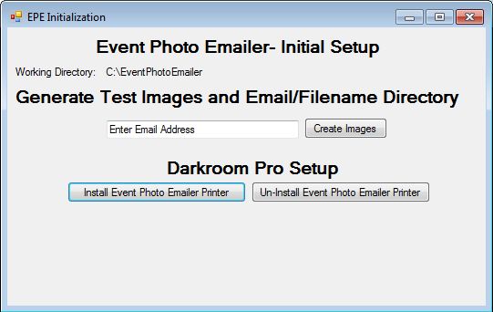

Figure 1: Screenshot of the EPE Initialization Form

**Generate Test Images and Email/Filename Directory**

This feature generates images to quickly test **Event Photo Emailer & Facebook Uploader** on your system. To do so, simply enter a test email address (usually your own) and click “Create Images”.

This does 2 things:

1. Copies 3 sample images into your image directory (usually c:\EventPhotoEmailer\EPE\_hotfolder) using a file naming convention incorporating your email address.
2. Creates a text file called “Email\_Filename\_Test\_Directory.csv” in the main folder (usually c:\EventPhotoEmailer) associating the sample images with the email addresses that you provide.

**Darkroom Pro® Setup**

If you have Darkroom Pro®, ensure that it is running and double-click the “Install Event Photo Emailer Printer” button. This is to ensure that the changes are made to the current x:\ drive. If Darkroom Pro®, is not running, the changes will need to be made manually.

**This setup does 3 things:**

1. *Adds three Event Photo Emailer Printers to* **Darkroom Pro®** *via your Window’s’ registry. These printers become visible in the Setup Section of Darkroom Pro. The three printers produce outputs with different aspect ratios with the maximum dimension defaulting to 600 pixels. (The values can be changed). You may get a message that your registry will be modified. You will want to choose the option to allow the change. The alternative is to set it up manually.*
2. *Copies the EventPhotoEmailer package group to the* **Darkroom Pro®** Package *Folder. If* **Darkroom Pro®** *is not running, you will have to do this manually by copying EventPhotoEmailer.pgrp into the C:\Program Files\ExpressDigital\Darkroom Pro\Packages folder.*
3. *Copies 2 sample “Proof Borders” to your* **Darkroom Pro®** *Template Folder.*

Running the Program

Run **Event Photo Emailer and Facebook Uploader** by double clicking the **EPEv4 shortcut** located either on the desktop or in the **Event Photo Emailer** folder in the Programs Menu. The firtst time you run it, you will be prompted to enter your passcode (Figure 2)

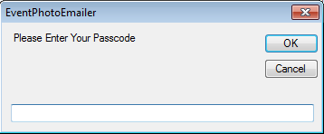

Figure 2: Screenshot of the passcode entry form.

This passcode is usually provided in an email from us. If you do not have one, choose OK and **Event Photo Emailer and Facebook Uploader** will default to Evaluation Mode which locks the Company name, reply-to email address, and the subject line to: “Evaluation Mode” on outgoing emails. For Facebook posts, the caption line will say “EPE4 Evaluation”. When finished, the window shown in Figure 3 appears.

The fields are populated with default values found in the file **c:\EPE\bin\default1.txt** If changes are made to these fields, they can be saved by clicking the **“Click here to save settings as the default”** button. The emailing process begins by clicking the green **SEND EMAILS** button or checking the **Send Emails Automatically** box. A description of each of the form’s item is given below:

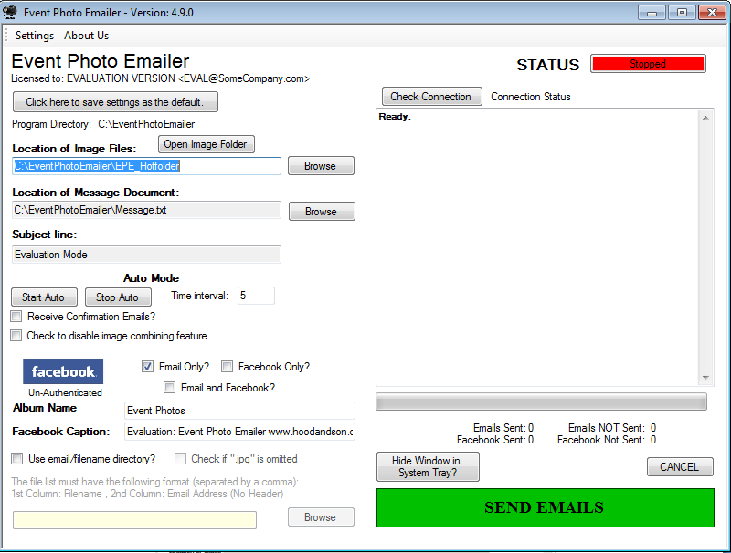

### Licensed to:

Each program is customized to the purchaser. For each email sent out, the “From” and “Reply To” fields are locked to the Company Name and email address that appears here. Only one license is needed for a company. This limitation acts to discourage sharing with other companies and allows the cost be held low. Each program is unlocked using a **Passcode.** If no **Passcode** is provided or the one provided is incorrect, the program will run in **Evaluation Mode** which locks the Company name to “Evaluation Version”, reply-to email address to EVAL@SomeCompany.com, and the subject line to: “Evaluation Mode”.

### Program Directory:

This field contains the directory that holds your program files. The default is c:\EventPhotoEmailer.

### Location of Image Files:

This is the folder that contains the images that you want to email. The default folder is c:\EventPhotoEmailer\EPE\_Hotfolder. This folder is easily accessed by clicking the “Open Image Folder” button.

### Location of Message File:

The body of each outgoing message is extracted from a text file. An example is given in c:\EventPhotoEmailer\message.txt. You can customize your own message(s) and save them as text files. You would then put the full path of your file here. It can be located anywhere on your computer.

### Subject Line:

This field contains the text that will appear on the subject line of your outgoing emails. If running in Evaluation Mode, this field is locked to “Evaluation Mode” and cannot be changed.

### Auto Mode

Auto Mode allows emails and/or Facebook posts to be sent out automatically. The Image Folder is periodically monitored for new images. The frequency is determined by the value, in seconds, in the Time Interval box. To start Auto Mode, simply press the Start Auto button. To end Auto Mode, press the Stop Auto button. Note: When this option is selected, only one event folder is created whose name is based on the date.

### Receive Confirmation Emails?

When this box is checked, an email is sent to the company email address in addition to each customer.

### Check to disable image combining feature?

**Event Photo Emailer and Facebook Uploader** will automatically take inventory of all the files associated with a given email address and combine them into a single email if this box is unchecked. If checked, an individual email is sent for each image file. If the image sizes are small and the numbers of images are few, it is recommended that this box be left unchecked. As an example, when working with proof sized .jpg images sized to 600 pixels x 400 pixels, the file size will range from 100kb to 200kb. There should be no problem sending between 10 and 20 images to a single email address.

### FACEBOOK

**Event Photo Emailer and Facebook Uploader** has 3 modes: Email Only, Facebook Only, and Email & Facebook. Only one checkbox can be selected. FACEBOOK requires authentication before images can be posted to a page. This can be done either by clicking on the FACEBOOK logo, or automatically with your first post. Below the FACEBOOK logo is a status line indicating if FACEBOOK has been already authenticated.

The Album Name is the name of the FACEBOOK album that the photos are uploaded to. If it does not exist, it will be created. If the ALBUM button is pressed, a drop down list of the current albums is created. To create a new one, simply type the new name in the box.

The FACEBOOK Caption field governs the caption for each image. Usually this is a generic description as it may be impractical to caption each image before it is sent.

### Use EMAIL FROM DIRECTORY?

This feature allows you directly use a pre-existing filename/email document in a comma delimited format (ie, .csv, or.txt) to quickly and easily send a large number of personalized emails. When the box is checked, a field appears that allows you to navigate to the file. The directory file can be created using any text editor or spreadsheet. If the document is created using a spreadsheet program like Microsoft Excel®, when saving, choose the file type to be .csv and the separating commas will be inserted automatically.

Below are two figures illustrating the layout of the directory file (Figure 3). The filenames are listed in the first column and the matching email address is listed in the second column. There is no limit on the number of files that can be listed.

|  |  |  |  |  |
| --- | --- | --- | --- | --- |
| |  |  | | --- | --- | | directoryfile_screenshot.jpg | directoryfile_screenshot_NoJPG.jpg | | a: with .jpg extension | b: without .jpg extension | |
| Figure 3: Email/Filename Directory Example |

Multiple files can be sent to a single email address by providing a semicolon between the filenames as shown in row 3 of Figure 3a. It is important to note that:

* No header is used (The first row begins with the first file)
* Each cell in the email column can contain only 1 email address.
* Neither the file names nor email addresses can contain spaces.

### Suppress .jpg extension

Since typing .jpg is a redundant process, clicking the **Do not use “.jpg” in email list** option will allow this requirement to be suppressed.

### STATUS BAR

This color bar indicates if the program is currently sending an email or posting to Facebook. If green, it is sending. If red, it has stopped.

### Check Internet Connection

Before sending emails or posting to Facebook, an internet connection is needed. This is usually not an issue when dealing with a hard wired connection. However, on-location Wi-Fi can be intermittent or even non-existent in some locations. This field indicates if an internet connection is available. One setup option (explained later) will check for a connection before sending each file. Another will disable this check. A check can be done at anytime by pressing the Check Connection button.

### Status Window

This window is the main source of feedback. It informs when images are sent/posted successfully and when there are errors. Below this window are 4 counters indicating the number of emails and posts successfully sent.

### Hide Window in System Tray

This button is used to minimize the window and allow Event Photo Emailer and Facebook Uploader to work in the background. This is usually done when the program is in Auto Mode. An icon will appear in your system tray. The make the window active again, right click on the tray icon and choose “Show EPE”

Email Configuration Editor

Figure 4: Email Configuration Editor

Clicking on **Settings,** located on the menu bar, produces the Email Configuration Editor (Figure 4). As is the case in the main windows, the fields get their default values from the c:\EventPhotoEmailer\bin\default1.txt file. For the quick startup, only the email fields will be addressed. The other fields are addressed later in this manual.

### Outgoing Email Server:

This is the web address used to send your emails. You can get this information from your Internet Service Provider (ISP). If you use Microsoft Outlook, you can get the settings from there by going to Tools/Account Settings/Email. For your convenience, a dropdown list provides the outgoing email server information for many of the popular ISP companies. If you are unsure of this information, contact your ISP’s website as they usually have the correct settings readily available.

### Port:

Normally email is sent via port 25 but some ISPs use a different port. For example, Comcast and Verizon FIOS uses port 587.

### Username:

This is the username that you use to sign into your email account. If you use Outlook, it will match that setting.

### Password:

Enter your email password here. Note: when **saving to default**, the password field is encrypted.

### Use SSL

If you are using an internet based web service like Hotmail, Yahoo, or Gmail, you will need to put a check mark next to “Use SSL”.[[2]](#footnote-2)

### Check for internet connection before sending

If this box is checked, a check is made to see if an internet connection is available. This is mainly used when using a Wi-Fi connection and you know that it is relativley unreliable. If you have a reliable internet connection, it is recommended that this box remain unchecked.

### Post Prompt for Email Address

If this box is checked, a prompt will appear asking for email addresses associated with a given photo. This feature is discussed in more detail later in this manual

### Configuration 1 and Configuration 2

Two configuration settings can be used. As an example, one can be setup to work on the office’s internet connection and the 2nd configuration can be for a mobile hot-spot internet connection. Simply click on the desired configuration button to make it active. The indicator located above the buttons tells which configuration is being used. Note: when saving, it is the current configuration file that’s being written to. When the program begins, it will always load configuration 1.

### Advertisement File

This field allows the attachment of another file in addition to the image when sending emails. Often, this is an advertisement file such as a flyer or business card. To make active, check the “Use advertisement file” box and then navigate to the file.

### Email Master List

If the checkbox is checked, a master list containing all email addresses collected. Currently, a status file is created for each event. In this status file, the email addresses associated with that event are tallied. The Email Master List is a running list of email addresses across events. To use, click the “Use Master List?” checkbox and provide a file to write to.

### Save and Close / Close without saving

Save and close will save the current field values (from the main window and the email configuration window) into the active configuration file. Close without saving will not write to the configuration files but the current field values are still used.

### Limitations

This program is designed to be used with Darkroom Pro®. It can also be used with Darkroom Assembly® however the [](http://moodle.raytownschools.org/file.php/1/windows-logo.jpg)+z macro (discussed later) is disabled. If you are using Darkroom Assembly®, contact us and we’ll send you a different build. These programs are not required if sending emails using the **Email From Directory** feature or the **Post Prompt for Email Feature**. Unfortunately, it will not work with any Darkroom Core® versions (including version 9) since this program does not produce a .jpg output file.

**Sending Test Emails**

When you return to the main window, make sure that “Email Only” box is checked and then click “Send Emails”. The status bar will let you know if you were successful. If you have difficulty sending these test files, you may want to verify your email server settings. You can also look at the troubleshooting FAQ at the end of this document. Note: If you are using Comcast or Verizon FIOS, the port number is 587. If you still are unable to send these files, please contact us.

**Posting Images to Facebook**

In addition to emailing, you can upload the images to **FACEBOOK**. To do this, click the box next to “Facebook Only”, choose an album name and Facebook Captions, and then click the green “Send to Facebook” button. The first time you do this, you will be prompted to log into Facebook. As before, the status bar will indicate if you were successful.

**Sending Emails and Posting Images to Facebook.**

It is possible to send emails and post images to Facebook. If you edit your message files such that there is a separator using 4 asterisks, “\*\*\*\*”, then the resulting Facebook link will also be included in the email.[[3]](#footnote-3)

**Sending Emails from an Email/Filename Directory**

It is possible to send emails and post images to Facebook using information in an email/filename text file. Check the “**Use email/filename directory?”** and a box appears asking you to enter the email/filename directory file.

Use the browse button to navigate to the sample file: **c:\EventPhotoEmailer\Email\_Filename\_Test\_Directory.csv**

In the Location of Image Files field, browse to:

c:\EventPhotoEmailer\bin\Email\_Filename\_Test\_Folder

Click **SEND EMAILS** and observe the status results.

If you have difficulty sending these test files, you may want to verify your email server settings. Note: If you are using **Comcast or Verizon FIOS**, the port number is **587**. If you still are unable to send these files, please contact us.

**How does it work?**

**Event Photo Emailer & Facebook Uploader** operates on the output file of your photo program. If **Darkroom Pro®** is used, the output would have a specific format that will allow the file to be emailed directly. If another photo program is used, the user will be prompted for the email addresses prior to sending. No special formatting is needed for uploading to Facebook.

.

## Program Outputs:

When the program is finished emailing images, a folder with a name that resembles Event\_0505201011533 is created inside your image folder. This name corresponds to the date and time the program started emailing. For example, this folder was created on 5/5/2010 at 11:53 am. It contains your relocated finished images as well as two documents: the Final Status Report (status.txt) and a .CSV file containing the extracted filename/email address directory (directory.csv). Note: Your original images are never touched.

Getting Started

This section will describe the **Event Photo Emailer & Facebook Uploader** workflow using the Darkroom Pro® v.8.9 software package. It is felt that the best way to explain the procedure is to use an example application. The scenario is similar to Example 1 described earlier. Recall, the goal is to take many portraits and email the clients their individual proofs. You should be able to tailor the instructions to your specific application. It is assumed Darkroom Pro® is in tethered capture mode however similar procedures are followed for importing images from the memory card. These instructions assume you have a working knowledge of the Darkroom Pro® software package.

During installation, two additions are made to your Darkroom Pro® software: three **Event Photo Emailer Raster Printers** are added to your printer group and an Event Photo Emailer package is added to your package groups. Also, an example proof border set is copied to your **x:\templates\ ProofBorderExample** folder. Since there is no automatic way to import the borders into Darkroom Pro, it has to be done manually.

The **Event Photo Emailer Raster Printer** acts like a normal printer but, instead of printing to a physical printer, it “Prints” to a file. The default setting for the **Event Photo Emailer Raster Printer** scales the newly created photo so that its maximum dimension is 600 pixels and the other dimension is either 429 pixels which preserves a 5:7 aspect ratio, () which preserves the 4:6 aspect ratio, and () which preserves the 8x10 aspect ratio.. These dimensions can easily be changed by clicking on the properties for this printer. It also assumes that that the new photos will be saved to the default location: c:\EventPhotoEmailer\EPE\_Hotfolder folder. If you would like them saved somewhere else, you will want to change the folder location. Note: you will want this location to match the image location you provide to the **Event Photo Emailer & Facebook Uploader** Program.

Note: The **Event Photo Emailer Raster Printers** reassigns the ‘A0’, ‘A1’, and ‘A2’ printers according to the following table:

|  |  |  |  |
| --- | --- | --- | --- |
| Printer Name | Aspect Ratio | Pixel Dimensions | Reassigned Raster Printer |
| EPE Raster Printer 600x400 AR:4x6 (based on A1) | **4x6** | **600x400** | **A1** |
| EPE Raster Printer 600x429 AR:5x7 (based on A0) | **5x7** | **600x429** | **A0** |
| EPE Raster Printer 600x480 AR:8x10 (based on A2) | **8x10** | **600x480** | **A2** |

These set of printers were chosen because they are rarely used and easy to remember. Therefore, printing to the raster printer named “**EPE Raster Printer 600x400 AR:4x6”** is done by choosing the ‘A1’ printer (located under ISO printers) as a package choice. Stated another way, all prints sent to the ‘A1’ printer are handled by the raster printer named “**EPE Raster Printer 600x400 AR:4x6”.** This is demonstrated in the **Event Photo Emailer Package Group.** You can either use this package group to create the files that you plan to email or you can add either ‘A0’,’A1’, or ‘A2’ to an existing package.

The Proof border set are based on a 5:7 aspect ratio and matches the setting for “**EPE Raster Printer 600x429 AR:5x7**”. To use them, you will first want to import them into Darkroom Pro®. They are located at X:\Templates\ProofBorderExample\. This set contains a horizontal and a vertical version which can be combined with all images before being emailed out. As mentioned earlier, your application can be different requiring a different type of template with different aspect ratio or no template at all.

Assigning Email Addresses

To ensure that emails are sent to the correct address, they must be first assigned to the image or group of images. Emails can be assigned to emails using two different methods. One method does this before placing the order and the other does it after placing the order.

## Assigning email addresses prior to placing orders

You can either work from the Program Library or Program Workshop. As you import images, you can assign the email addresses to the photo or group of photos in the following way:

* Select the image or group of images you wish to assign the email(s) to
* Hit the keyboard combination [](http://moodle.raytownschools.org/file.php/1/windows-logo.jpg)+z as shown in Figure 5.

This combination is achieved by holding down the [](http://moodle.raytownschools.org/file.php/1/windows-logo.jpg) key and z key at the same time. If your keyboard lacks this key, then the macro is achieved using the 3 key combination of Ctrl+Esc+Z

|  |
| --- |
| WindowsZCombo.jpg |
| **Figure 5: [http://ts1.mm.bing.net/images/thumbnail.aspx?q=1513790705516&id=48c3f3778ba5416c400b3fd3df5621f6&url=http%3a%2f%2fmoodle.raytownschools.org%2ffile.php%2f1%2fwindows-logo.jpg](http://moodle.raytownschools.org/file.php/1/windows-logo.jpg)+Z macro combination** |

Type in the email addresses(es) when a box appears asking for it. Hit OK, then OK again to exit. This assigns the email address to all of the highlighted images. Ideally, you will repeat this procedure until you are finished shooting.

If the [](http://moodle.raytownschools.org/file.php/1/windows-logo.jpg)+z does not bring up the email box, the following procedure can be used in its place:

* Highlight the image or group of images
* Hit CTRL-TAB (brings up the photo data window)
* Click on “Add Data”
* in the “Properties Field” type the word email
* in the “Value” field, type the email address.
* Hit OK, and then OK again.

### Assigning multiple emails to an image

**Event Photo Emailer and Facebook Uploader** supports multiple emails being assigned to a single image. Due to Darkroom’s handling of many of the common delimiters, the program has been setup to recognize the different emails being separated by Exclamation points ‘!’. For example:

[bill.gates@microsoft.com!SteveJ@apple.com](mailto:bill.gates@microsoft.com!SteveJ@apple.com)

## Assigning email addresses after placing orders

If the “Post Prompt for Email Address” checkbox is checked, after placing an order, a window will appear asking for corresponding emails (Figure 5).

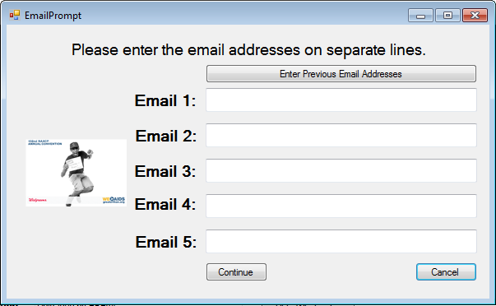

Up to 5 email addresses can be assigned to a single image. This box appears for each processed image. If the email address for a current image matches that of the previous image, simply click the “Enter Previous Email Addresses” button. When finished, hit continue.

Batch Generating the images to be emailed

* Highlight all the images you wish to send
* Click the ‘Batch’ icon located at the top. A new window will appear (Figure 6)
* Click “Print only Selected Photos”.
* On “Choose the prints to make for each photo”, click Add and choose the Email item. Note: The Event Photo Emailer package (or one that contains the ‘A0’ item ), must be active)
* In “Apply a border” choose “Print Each Photo with a border” and choose one of the two borders. Note: if you create companion borders and name one (Horizontal) and the other (Vertical), Darkroom Pro® will be able to discriminate between the portrait mode and landscape mode photos and automatically apply the appropriate border
* In “How to create the print order” choose Create a single order
* Either **PLACE THE ORDER** or **SAVE THE ORDER**. Note: If you **PLACE THE ORDER**, the images are compiled and saved to your pre-determined email folder. If you choose **SAVE THE ORDER**, the order will be sent to your **ORDERS SECTION**. The benefit of this is that you can review the final image with the border and make final adjustments before producing the final product.

|  |
| --- |
| ScreenShot_BatchApply.jpg |
| **Figure 6: Screenshot Batch Printing with borders** |

Posting to Facebook

Posting to Facebook is easier than sending an email. Simply make sure that the “Facebook Only” box is checked. When you place your order, items being handled by the A0, A1, or A2 raster printers are posted to Facebook. If Facebook was not already authenticated by clicking the Facebook icon, the window will appear for the first posting (Figure 7). All subsequent postings are sent directly.

**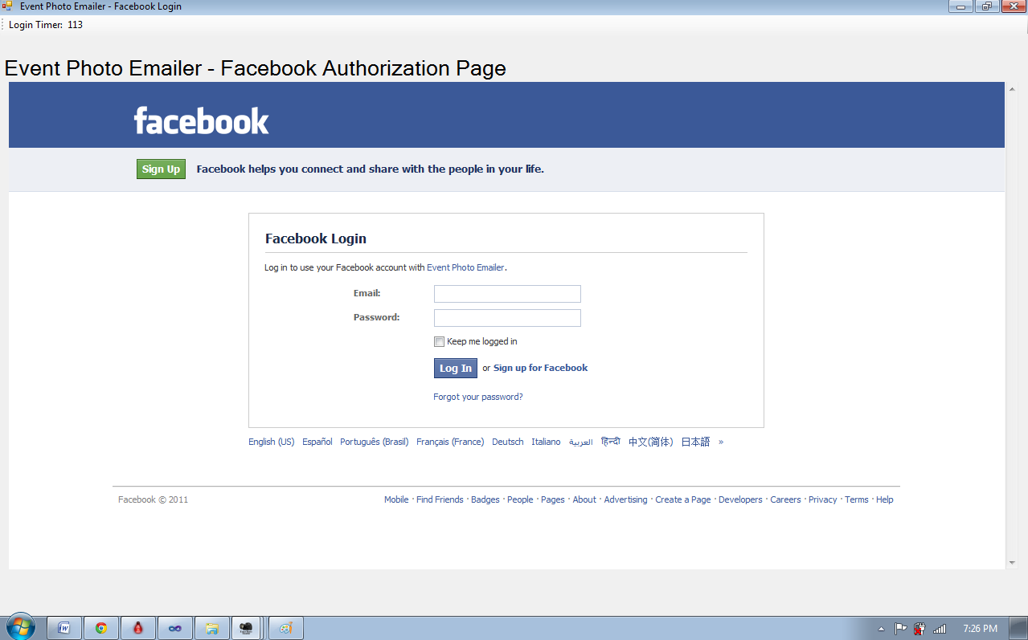**

**Figure 7: FACEBOOK authentication window**

If the “Facebook and Email” checkbox is checked, an email will go out in addition to the Facebook post. If the message document uses 4 stars to separate the message from the salutation (Figure 8) the 4 stars will be replaced by a direct link to the image on the Facebook (Figure 9)

|  |
| --- |
| **Dear Customer,**  **Here is the digital image that we promised from your recent event.**  **We hope that you are pleased with your image and we appreciate your business!**  **\*\*\*\***  **Mr. Big**  **Owner**  **The Man Photography**  **301-437-1186** |

|  |
| --- |
| **Dear Customer,**  **Here is the digital image that we promised from your recent event.**  **We hope that you are pleased with your image and we appreciate your business!**  **Your image has also been uploaded to Facebook:** [**http://www.facebook.com/media/set/\?set=a.10150192528181035.10150192528181035.601201044**](http://www.facebook.com/media/set/\?set=a.10150192528181035.10150192528181035.601201044)  **Mr. Big**  **Owner**  **The Man Photography**  **301-437-1186** |

FAQ

# Known issues:

Here are a few known issues that may need to be addressed to ensure the program operates properly.

### Anti-Virus software:

If you have anti-virus software running, it is possible that it is setup to allow only the popular email programs like Outlook, Eudora, etc. to send out emails and may prevent this program from sending emails. The remedy is to add this program in your anti-virus software’s safe list.

Also, your virus protection software may scan all outgoing files. This adversely affects how fast emails are sent out. Most Anti-Virus programs allow this feature to be disabled.

### ISP limit outgoing emails

Most ISPs place a limit on the number of emails that can be sent out in a given period of time. You will want to check with your ISP, however typical numbers are in the range of 250 to 500 emails per day, per email account.

### All images are assumed to be jpegs and have a .jpg extension.

Images files that do not contain the “.jpg” file extension are ignored by the **Event Photo Emailer** engine. The program is not case sensitive so .jpg, .JPG, .Jpg will all be recognized. If other file types are needed, please feel free to contact me.

### The workflow assumes you are not using the A0, A1, and A2 raster printers.

This workflow re-assigns the use of the **A0, A1, and A2** raster printers.

### Microsoft Excel .csv file must be closed

If you have a pre-existing email/filename directory saved as a .csv file, it must not be open in Microsoft Excel while the **Event Photo Emailer** engine is running. Excel locks the file and the **Event Photo Emailer** engine will not be able to access it. If you need the directory file open at the same time, you can open it in a text editor like **Windows NOTEPAD**.

### Windows User Account Control (UAC)

On Windows Vista and Windows 7 machines, when you run **EventPhotoEmailer.exe**, you may be prompted with the UAC control dialog box. If so, simply click yes.

## Closing statements

This program should provide you with a powerful tool to directly market to your customers and hopefully put a spark in those online and well as on-site sales. Although the impetus to creating this program was for the on-site, multiple portrait scenario, undoubtedly, the talented group of individual for which this program is targeted will come up with some amazing new applications. I would love to hear them! If you have any questions, concerns, suggestions, or would just like to provide feedback, please use the following email address: [info@hoodandson.com](mailto:info@hoodandson.com) or call me directly at: 301-437-1186

New features will continue to be added based on the feedback obtained.

Thank you,

Adrian Hood, Event Photo Emailer Developer ©2011

1. Darkroom Pro is not required to benefit from Event Photo Emailer & Facebook Uploader. Additional “Plug-ins” can be easily developed. [↑](#footnote-ref-1)
2. For these services, the reply-to address must be consistent with the email service provider. [↑](#footnote-ref-2)
3. The emailed individual will still get the photo but will have to have a Facebook account to follow the link. [↑](#footnote-ref-3)